TASK 1:
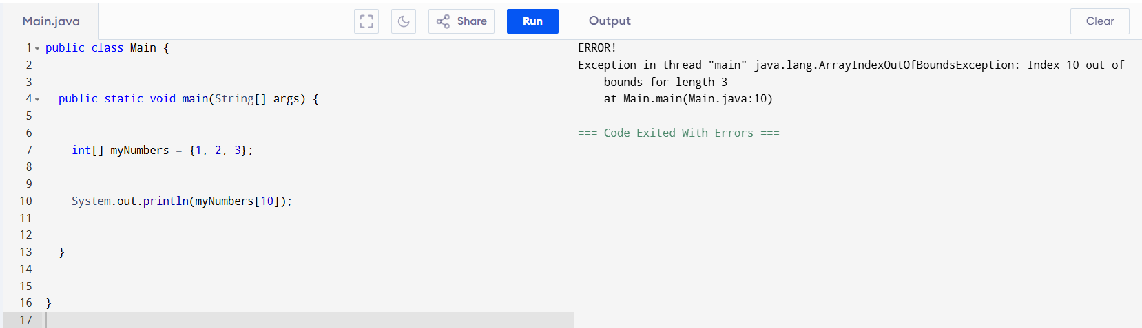
Task 2:
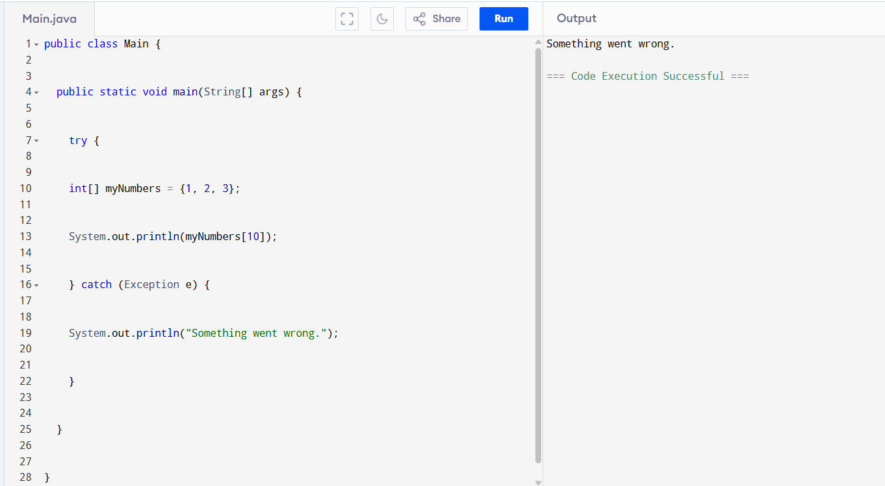
Task3 :
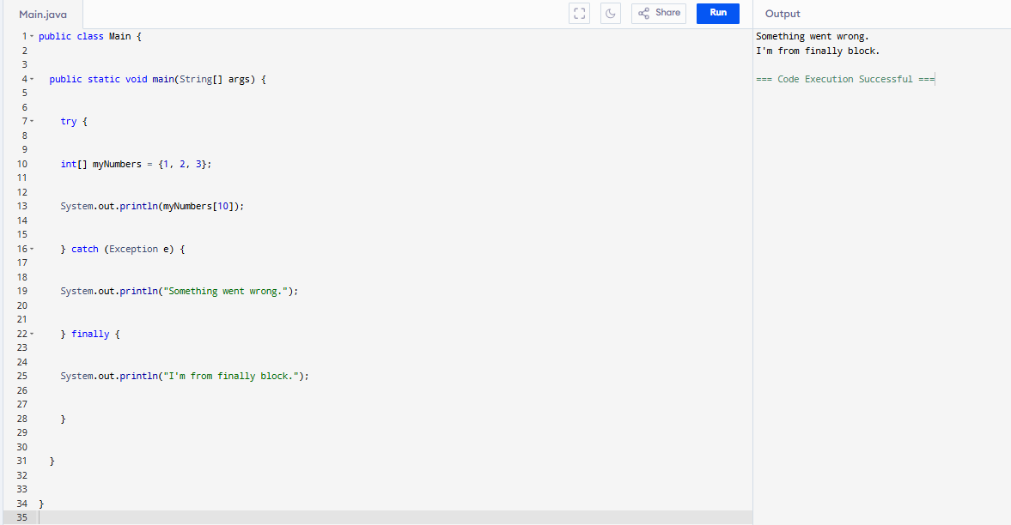
Task 3.1:
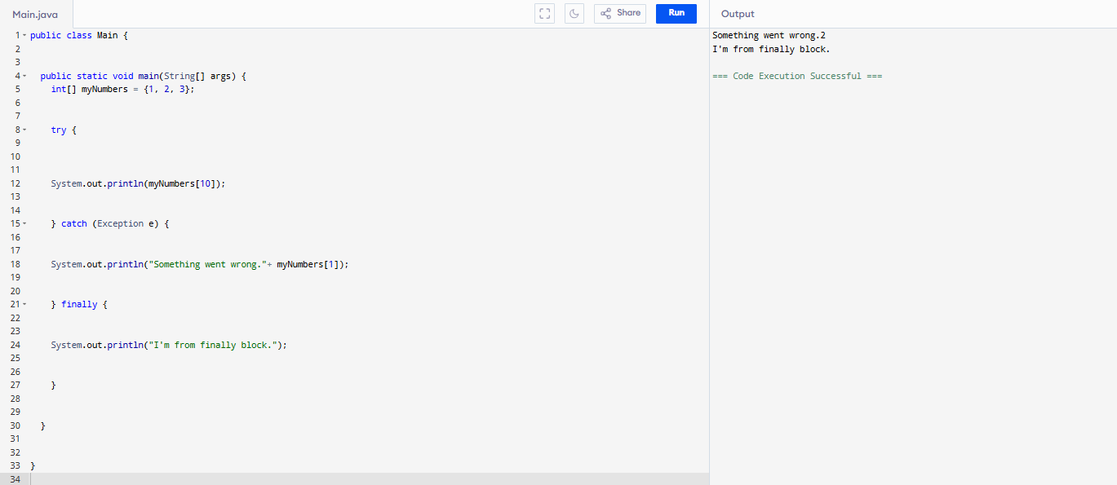
Task 4:
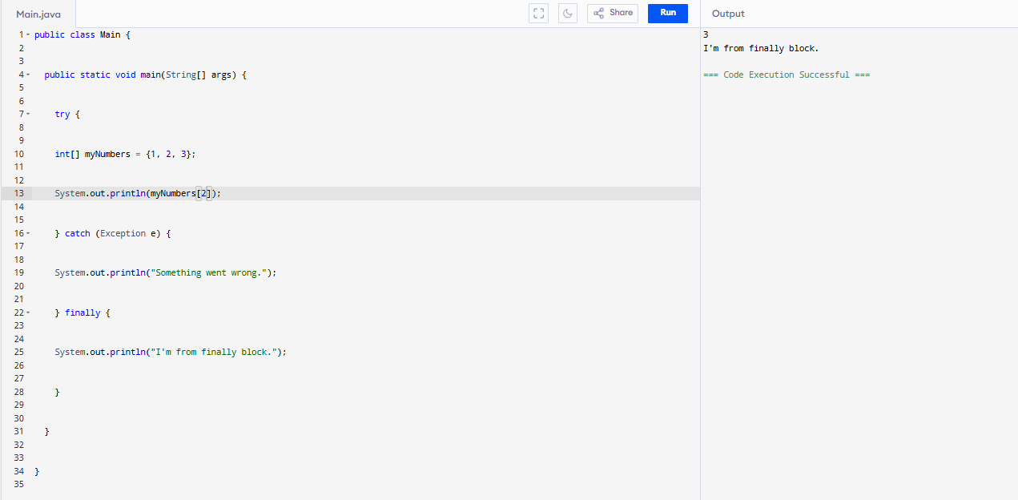
Task 5:
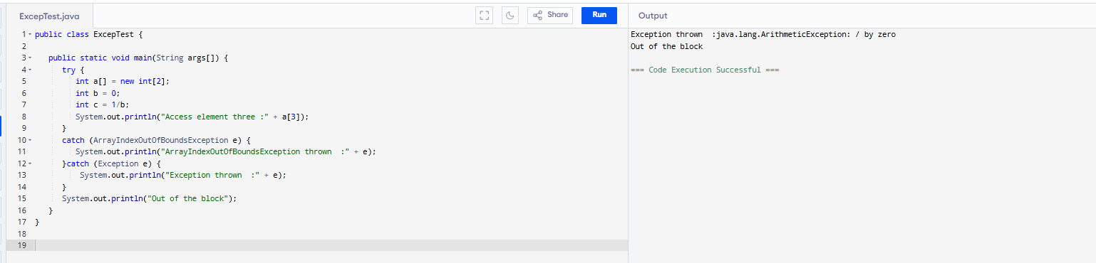
Task 6:
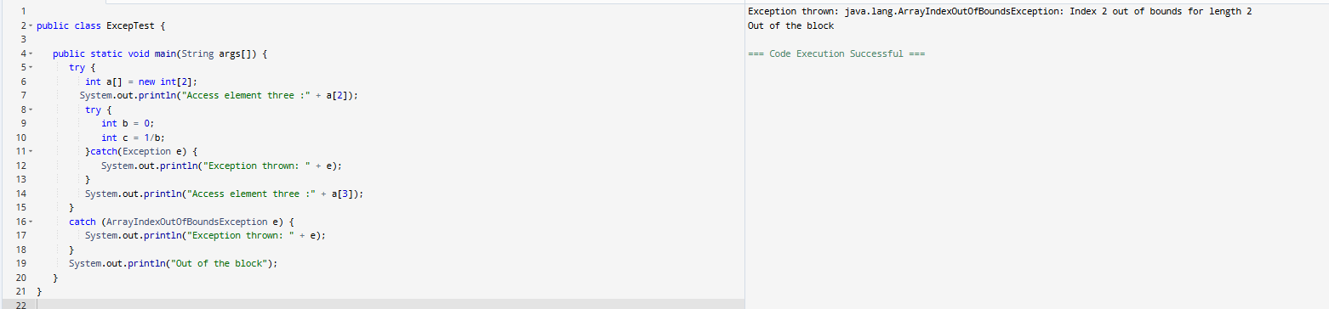
Task 7:
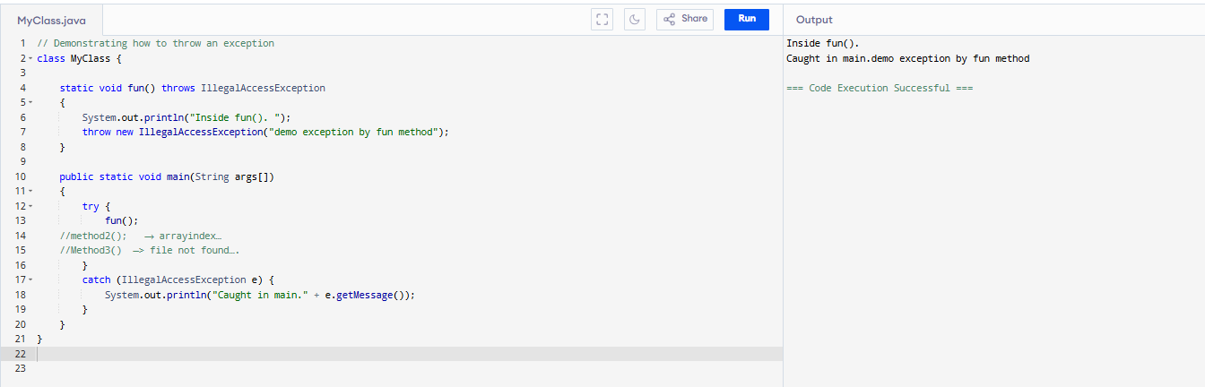Task 8:
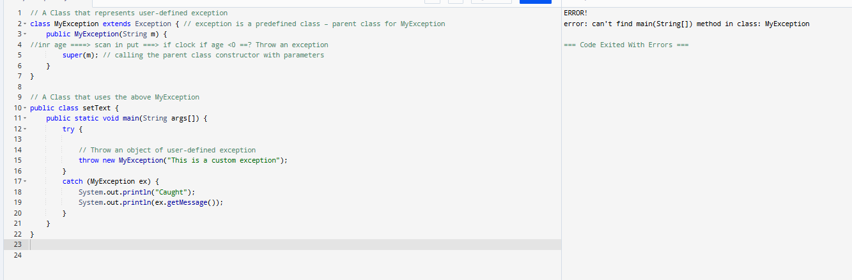

Task 9:
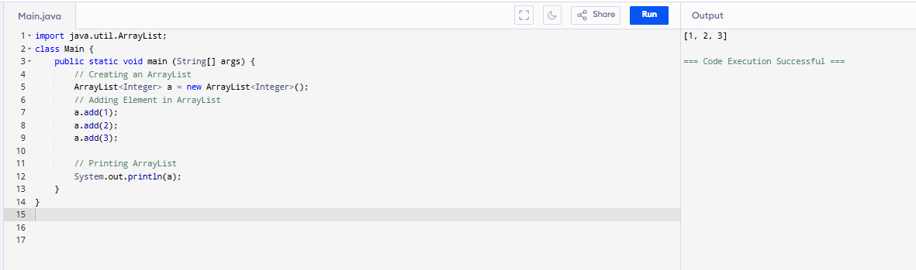
Task 10:
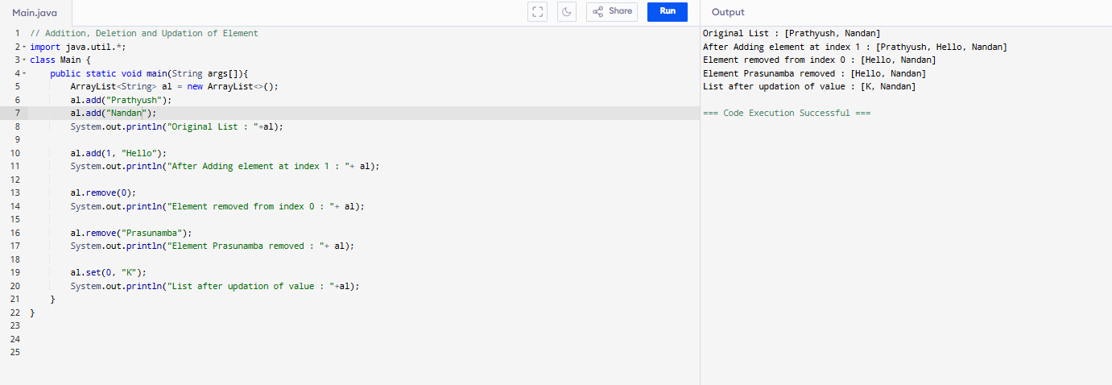
Task 11:
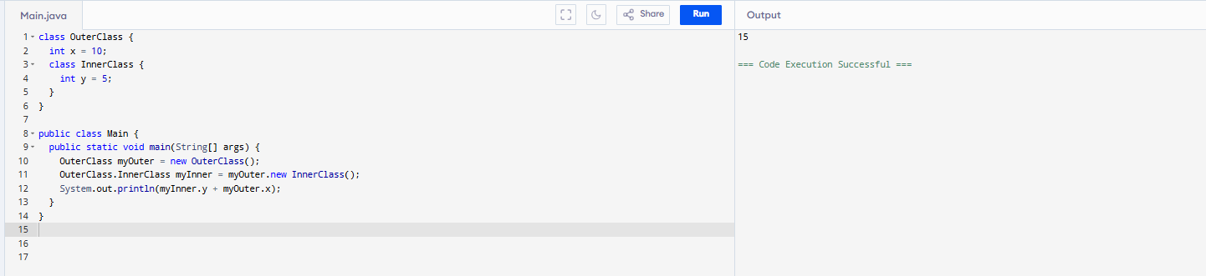
Task 12:
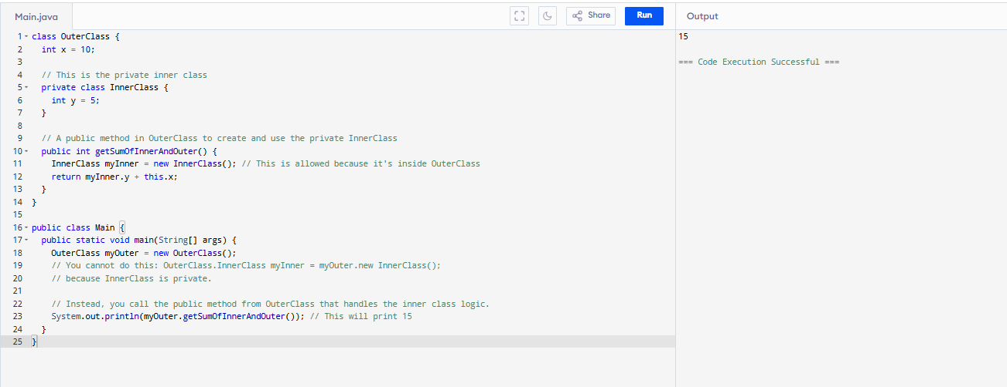
Task 13:
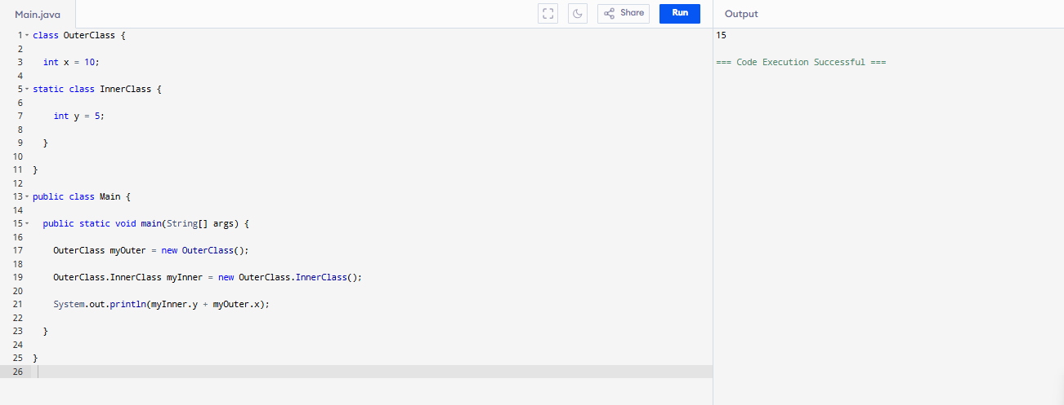
Task 14:
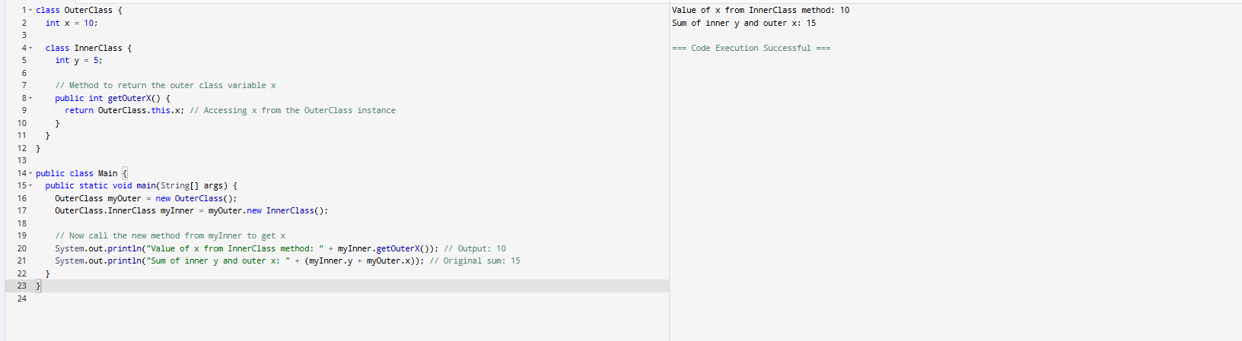
Task 15:
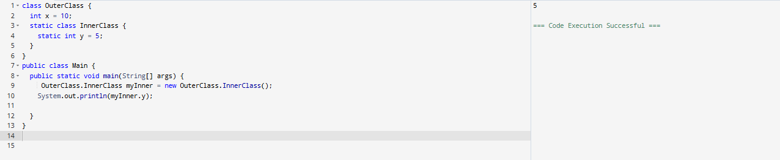
Task 16:
What are the features of java 8?

- Lambda Expressions: This is arguably the most significant feature. Lambda expressions provide a concise way to represent anonymous functions, allowing you to treat functionality as a method argument or to define anonymous methods more cleanly. They enable functional programming in Java.
- Functional Interfaces: An interface with exactly one abstract method is called a functional interface (also known as a Single Abstract Method or SAM interface). Lambda expressions are used to provide the implementation for these interfaces. The @FunctionalInterface annotation is used to mark an interface as a functional interface, helping to avoid accidental addition of abstract methods.
- Stream API: The Stream API (in the java.util.stream package) provides a powerful and expressive way to process sequences of elements (like collections) in a functional style. It allows for operations like filtering, mapping, and reducing data, and supports both sequential and parallel execution, making it efficient for large datasets.
- Default and Static Methods in Interfaces: Prior to Java 8, interfaces could only have abstract methods. Java 8 introduced the ability to add default methods (with implementations) and static methods to interfaces.
  - Default methods provide backward compatibility, allowing new methods to be added to existing interfaces without breaking existing implementations.
  - Static methods in interfaces are utility methods associated with the interface itself, not with any specific implementation.
- Date and Time API (java.time package): Java 8 introduced a completely new and improved Date and Time API, addressing the shortcomings of the old java.util.Date and java.util.Calendar classes. The new API is immutable, thread-safe, and provides clear distinctions between dates, times, and date-times, as well as better handling of time zones. Key classes include LocalDate, LocalTime, LocalDateTime, ZonedDateTime, and DateTimeFormatter.
- Optional Class: The java.util.Optional<T> class is a container object that may or may not contain a non-null value. It helps in dealing with null references more gracefully and reduces the risk of NullPointerExceptions by forcing developers to explicitly handle the absence of a value.
- Method References: Method references provide a concise syntax for referring to methods or constructors without invoking them. They can be used in conjunction with lambda expressions for even more compact and readable code when a lambda expression just calls an existing method.
- forEach() Method in Iterable Interface: The Iterable interface now has a forEach() default method, which allows for a cleaner way to iterate over collections using lambda expressions, reducing boilerplate code compared to traditional for-each loops.
- Parallel Array Sorting: Java 8 introduced Arrays.parallelSort() methods, which leverage the Fork/Join framework to sort arrays in parallel, offering performance improvements for large arrays on multi-core systems.
- Nashorn JavaScript Engine: This is a new JavaScript engine that allows developers to embed JavaScript code within Java applications and provides improved performance and compliance with ECMAScript standards.
- Base64 Encoding and Decoding: Java 8 added built-in support for Base64 encoding and decoding, simplifying common data manipulation tasks.
- Concurrency Enhancements: While the core concurrency model remained similar, Java 8 brought improvements and new classes (like CompletableFuture) for more efficient parallel processing.
These features collectively made Java 8 a very influential release, significantly enhancing the language's capabilities for modern software development, especially in areas like functional programming and concurrency.
Task 18:
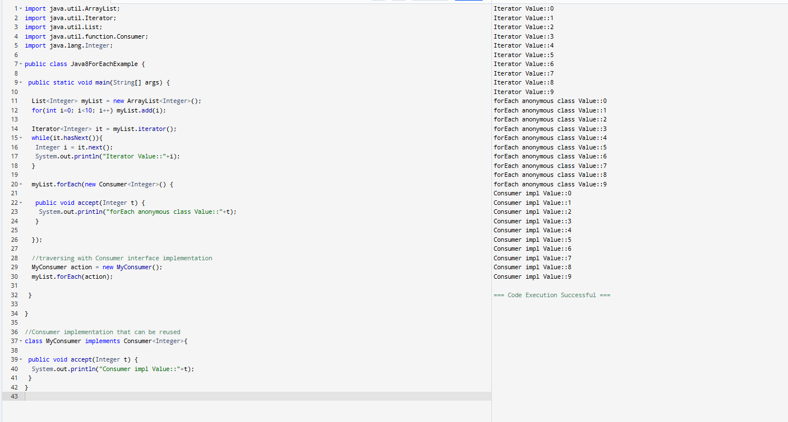
Task 19:
https://www.digitalocean.com/community/tutorials/java-8-features-with-examples
Plz go through this link for Java 8 features..

Task 20:
import java.util.*;
public class CollectionsDemo {

public static void main(String[] args) {
// ArrayList
List a1 = new ArrayList();
a1.add("Zara");
a1.add("Mahnaz");
a1.add("Ayan");
System.out.println(" ArrayList Elements");
System.out.print("\t" + a1);

// LinkedList
List l1 = new LinkedList();
l1.add("Zara");
l1.add("Mahnaz");
l1.add("Ayan");
System.out.println();
System.out.println(" LinkedList Elements");
System.out.print("\t" + l1);

// HashSet
Set s1 = new HashSet();
s1.add("Zara");
s1.add("Mahnaz");
s1.add("Ayan");
System.out.println();
System.out.println(" Set Elements");
System.out.print("\t" + s1);

// HashMap
Map m1 = new HashMap();
m1.put("Zara", "8");
m1.put("Mahnaz", "31");
m1.put("Ayan", "12");
m1.put("Daisy", "14");
System.out.println();
System.out.println(" Map Elements");
System.out.print("\t" + m1);
}
}

